Contents

Site Description 1

Users and Purposes 2

User 1 2

User 2 3

User 3 3

Flaw Analysis 4

Home page 4

Navigation 4

Layout 4

Color 5

Fonts 5

Locations page 6

Layout 6

Font 6

Careers Page 8

Navigation 8

Layout 8

Color 8

Font 8

Alternatives / Competitor Analysis 10

Menu 11

Call Ahead / Wait List 12

Career Information 12

Proposal 14

# **Site Description**

Site being analyzed: saltgrass.com

As a privately-owned business, your company (Saltgrass Steakhouse) relies solely on the appeal of your goods and services. Consumers must be persuaded to eat the food prepared by your restaurants, and convinced that they will be easily seated within a reasonable amount of time. Additionally, individuals should be able to apply for available positions at your restaurants have openings. Your website is a tool to accomplish the three main goals of the main users of your service, and thus should be as user friendly and visually appealing as possible while still delivering on the above objectives.

This document will serve to outline key areas where your site fails in ease of use and design by analyzing the difficulty of completing certain tasks pertaining to what your site serves to accomplish. We will point out these areas through visuals, as well as example user experiences. Additionally, we will compare your site to a competitor’s site (in this case Outback Steakhouse) so as to better show where your site could improve in terms of usability and visual design. It is vital to examine varying aspects of your site’s usability and design as it will allow you to remain competitive with others in the same industry, as well as easily attract new customers by having a good first impression when they visit your site.

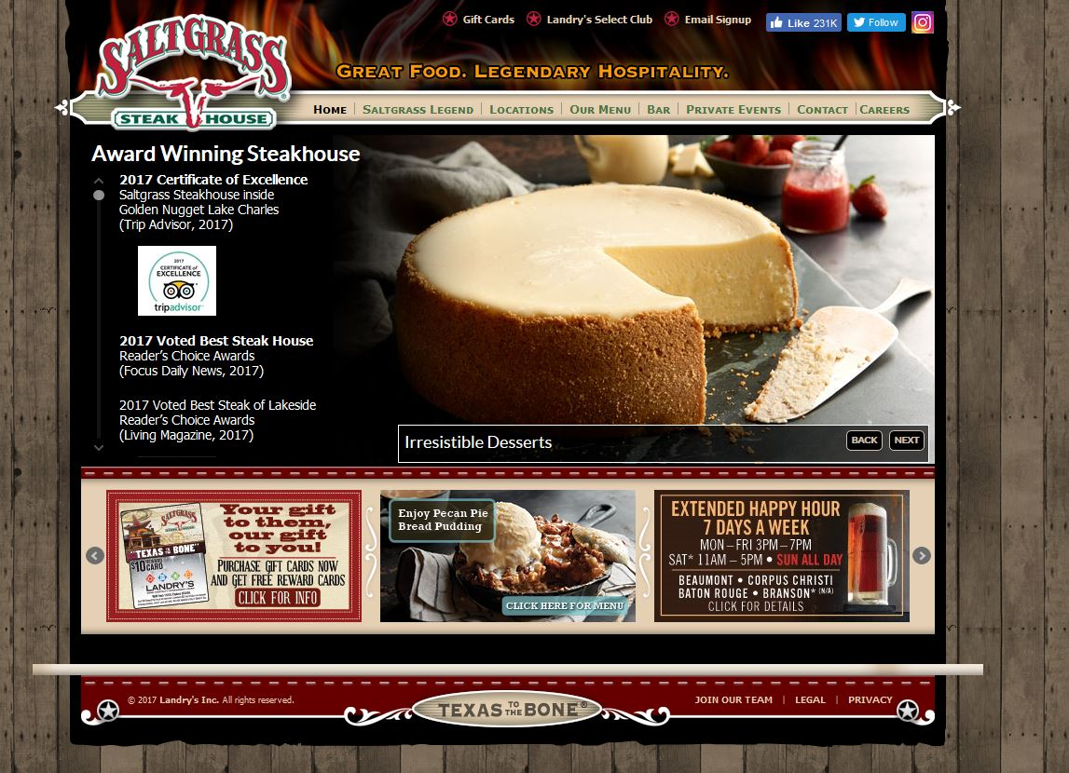

Figure 1: This figure showcases the Saltgrass homepage

# **Users and Purposes**

Saltgrass Steakhouse Users generally fall into 1 of 3 categories:

* A consumer interested in viewing the menu and prices
* A consumer who wants to make a reservation or call ahead for seating
* An individual interested in applying for a job

These 3 different types of users will navigate your website differently based on their specific goals, however each user must be able to accomplish their goals in a time-effective and frustration free manner so as to increase the chances that they return to your site and your restaurant. By creating a site that caters to the three user types listed above, you will be catering your site to the largest audience possible, and thus allowing information about your restaurant to spread and reach as large a population as possible.

## **User 1**

Jane Doe is a stay at home mom who likes taking her kids out for special surprise dinners once a month. Her kids, however, are what some might call picky eaters. Jane often must visit a restaurant’s website before paying a visit in person to ensure that the restaurant’s menu will have something on it that her kids will enjoy. Finding an easy to access online menu for a restaurant is extremely important to Jane.

* Name: Jane Doe
* Age: 45
* Occupation: Stay at home mom of 2
* Hometown: San Antonio, TX
* Interests: Saving money and making sure her family has a good time

## 

## **User 2**

John Smith is an engineer at Devon Energy. He is a husband to a loving wife and a father who likes to please his rather impatient children. When going out with his family to dinner, John oftentimes calls ahead or goes online to place his name on the list so as to avoid waiting too long once arriving at a restaurant. Easily finding call ahead / reservation information online is a must for John when deciding where to eat with his family.

* Name: John Smith
* Age: 27
* Occupation: Engineer
* Hometown: Oklahoma City, OK
* Interests: Having a good time with his family, eating out, bowling

## **User 3**

Ron Swanson is an up-and-coming steak chef and is looking to apply for a job to hone his grilling skills to make it big. He is not very tech-savvy, and often has trouble navigating overly complicated websites. Being able to find information on applying for a job at steakhouses is critical to Ron’s success in the chef business.

* Name: Ron Swanson
* Age: 34
* Occupation: Steak chef
* Hometown: Pawnee, IN
* Interests: Not spending a large amount of money while showing the world his talent as a cook

# **Flaw Analysis**

During this step of the consulting process, we will review the three most significant pages of your website: the home page, the locations page, and the careers page. Our focus is how to improve the navigation, layout, color, and fonts.

## **Home page**

Often, a first impression is the key to engaging a user. Like a weak handshake that brings mistrust to a new relationship, a poor designed home page can overwhelm and frustrate a

users. Your home page looks good for the most part, but needs a few changes to make it easier and helpful to your users. We have provided a few ways that you can use for your site to better assist those who use it.

### **Navigation**

The first thing that stuck out to us was the home page not having a search bar. The search bar is an important factor in having a well-organized website. If a user needs to find something quick on your website such as a specific locations phone number, they would need to navigate through your site using the navigation bar and guessing where the information they are looking for might be. Our solution for this is labeled in **Figure 2.1** above with a good location picked out.

### **Layout**

The overall theme of the home page layout fits that of a good steak house. It would grab a steak enthusiast’s attention by the southern look it tries to portray. However, there are quite a few mistakes that need to be addressed:

* There are too many advertisements, which clutter the homepage and make it appear busy to users
* There are rotating images (similar to a slideshow) throughout the homepage that flip through multiple images very quickly, distracting the user from whatever they come to your site for
* Your “Saltgrass Legend” section is the first item on the navigation bar, and is something that is not usually a high priority for someone visiting at this site
* Having all your awards on the front page also distracts the user from their objective by providing them with information that they do not need nor in most cases want

We have labeled areas in **Figure 2.1** above to show where these possible mistakes are located. We have also provided solutions to the mistakes we have listed;

* If you are going to use advertisements (such as those on the bottom of your current homepage), make them smaller and move them into a less conspicuous spot, such as a corner
* When using slide shows like the one in the center of your homepage, make sure the speed at which the slide show flips through images is slow enough for users to fully read/view what is on each image
* Move the “Saltgrass Legend” farther to the right since it has a smaller priority.
* Move your awards to the navigation bar, because not every user will care to look at them.

### **Color**

We love the color scheme: the dark red, light brown, bright white, and blacks all flow wonderfully. The flames have a great tone of color to make them feel warm. The fence for the second background has a nice light brown that gives them a rustic look. We noticed that the links on the home page have a light color to them. Maybe try and make them bolder to let the viewer know that they are links.

### **Fonts**

Sans serif was a decent decision; however, your site will appear more rustic if you move away from Open Sans. We feel that the font should be changed throughout the whole website. You should try and match the font of your logo. It will give the website that rustic look we had just mentioned.

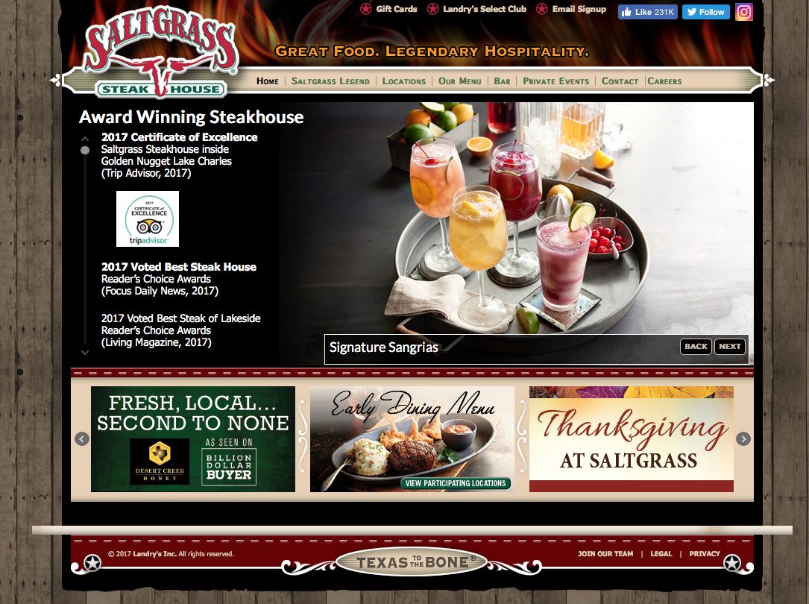

Reorganize links by priority

Add a search bar here

Do not use sliders

Figure 2.2: Home Page

## **Locations page**

For you to achieve your goals of enticing and sustaining customers, this webpage needs to be as easily navigable as possible. All vital information pertaining to a location, such as address, phone number, and hours, should be clearly visible and

### **Layout**

The website layout has changed slightly, but still has rotating images that are not necessary. It is odd that the first location listed is for Houston, Texas as shown in **Figure 2.3** below, as most would assume a drop-down menu to be alphabetical. You only need to keep the “see a list of restaurants by state:” tab, because users need to feel like this restaurant is special for any state. The links listed on this page are small and not easily identifiable as links. This page is time consuming because it is also the page that you must go through to find a menu for a specific location.

### **Font**

Most of the issues with the font are simple fixes that were easy to overlook when creating this webpage. The sub-header for “Our Locations” uses two different font sizes which makes it look uneven. Try and keep them the same size for more even look. Additionally, the actual information about each location is shown in a very small font that can be hard to read for those with poor eyesight. We would recommend making this information large and easy to view from a distance.

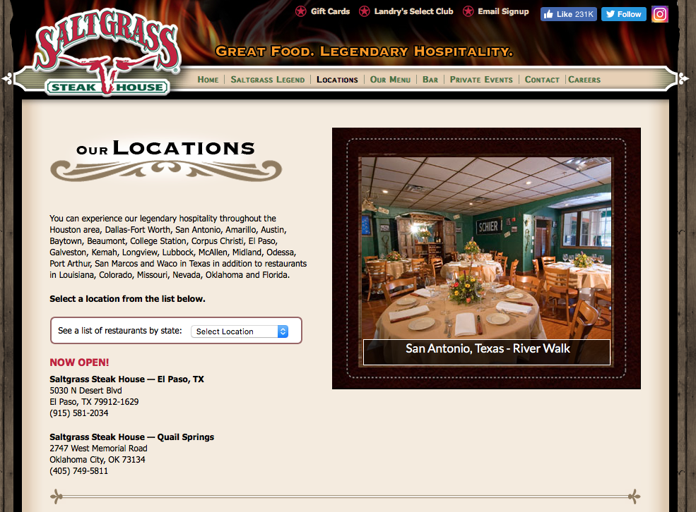

Poorly designed

Avoid using slider

Figure 2.2: Locations Page

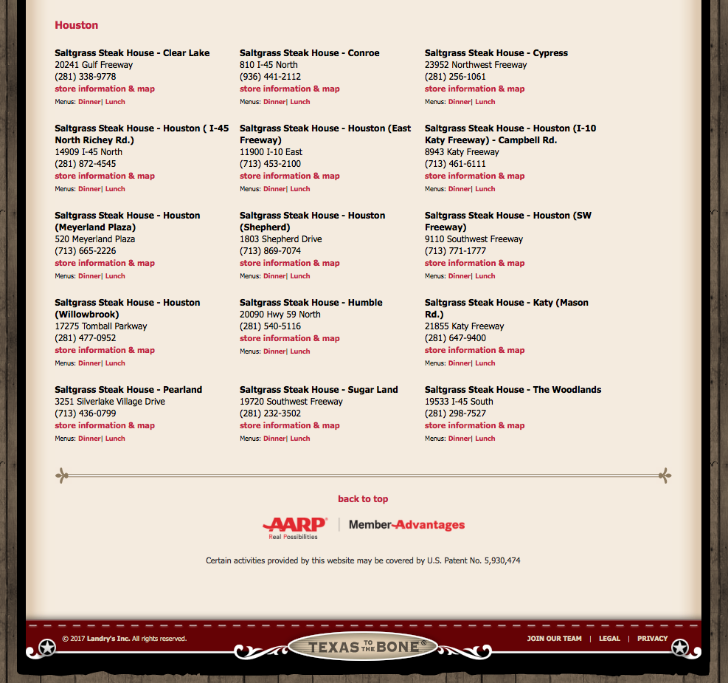

Figure 2.3: Locations Page Continued

Why does the first location come up as Houston?

## **Careers Page**

The careers page is a great way to bring in potential employees. You want this to page to look professional and easy to use, and provide easy to access information on applying for a job as well as any open positions available.

### **Navigation**

The first thing we had a problem with was clicking the “careers tab” on the navigation bar from the home page. It opens another page in the web browser and can be confusing and frustrating for your future employees. We see you added a search bar for this page, but it is only for entering zip codes. Try and add an all in one search bar in that same location as shown in **Figure** **2.1** so as to allow users to search by keyword such as a specific position, location, etc.

### **Layout**

The layout of each linked page is basically the same in terms of look and usability. The use of all the bullets in “Job Opportunities” in **Figure 2.4** below is very overwhelming and can be time consuming for the users to ready through. We suggest using a drop-down menu that will allow the user to look up a position in an alphabetically ordered list, rather than seeing a lot of information shown to them on the page at once.

### **Color**

The coloring in **Figures 2.4 and 2.5** are all the same plane red and whites, which is good as it does not distract the user. Good coloring can keep the user focused, which will help them fill out the job inquiry form more accurately.

### **Font**

Your fonts can be viewed in **Figures 2.4 and 2.5**. While the fonts themselves are good and contrast well with the white background, the font size is quite small. This fact is compounded when the user is faced with the large walls of text currently present on nearly every page on this site. We would recommend breaking the large blocks of text into subsections to make them more easily digestible. Additionally, try not to embed links within paragraphs of text, as these can be easily overlooked by users who do not pay close attention to the font color when reading.

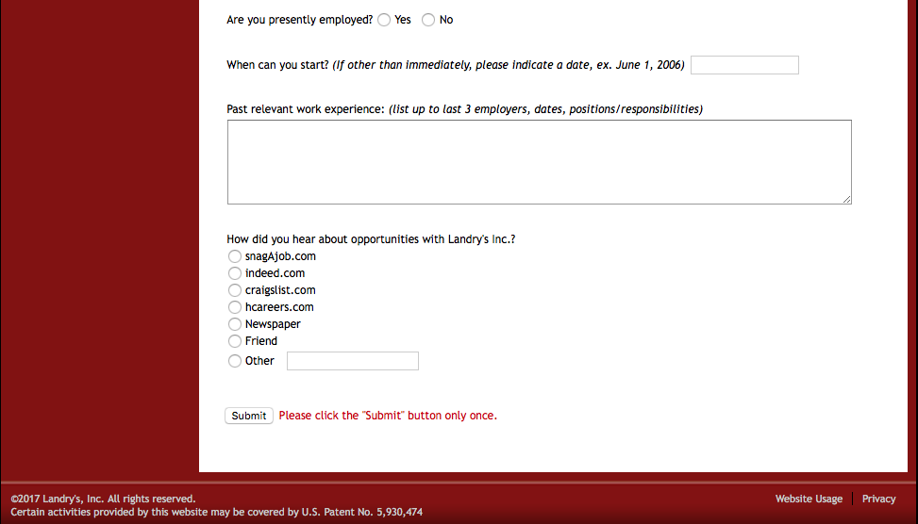

These are for actual jobs, not inquiry’s

Figure 2.6: Restaurant Staff Inquiry Form Continued

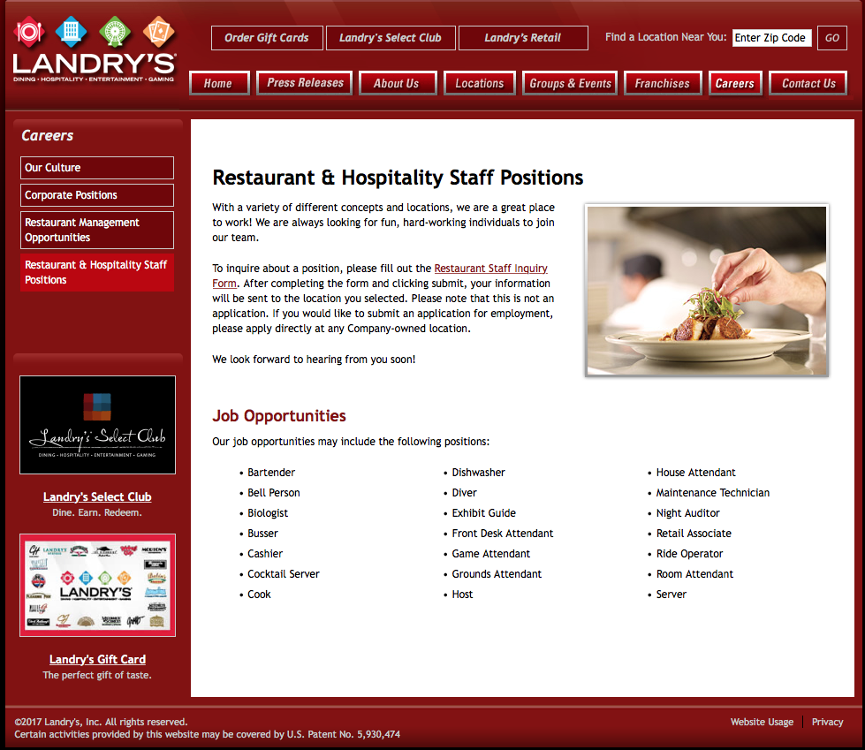

This link is not very visible

Again, get rid of this

Why not show what is currently available?

Figure 2.5: Restaurant & Hospitality Staff Positions Page

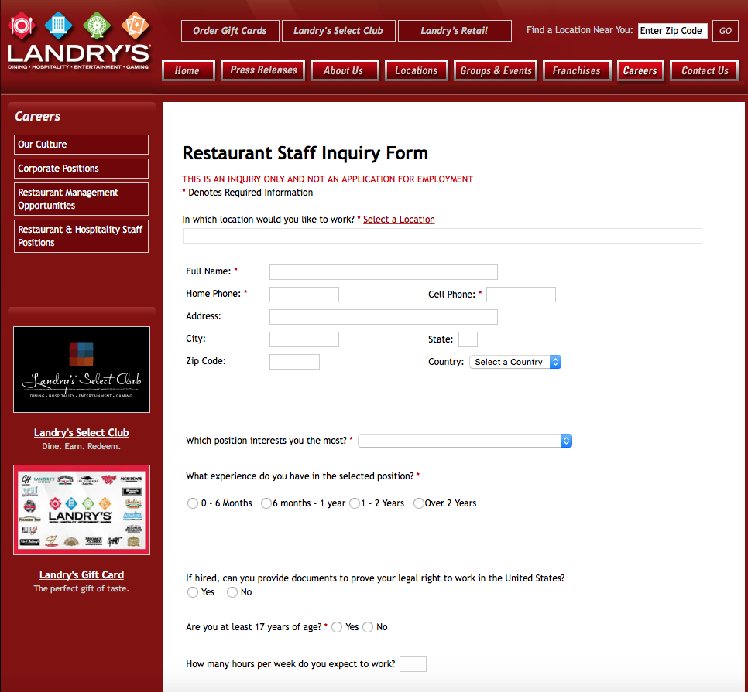

Get rid of this!

Then what is the point of this form then?

Figure 2.4: Restaurant Staff Inquiry Form

# **Alternatives / Competitor Analysis**

Competitor being analyzed: Outback Steakhouse (outback.com)

Outback Steakhouse’s website works in a more user friendly and user efficient manner in accomplishing the same tasks that Saltgrass’ website attempts to accomplish in a number of ways. We will analyze Outback’s website in comparison to Saltgrass’ through examining its homepage, its menu page, its call ahead / wait list page, and its career information page.

**Home Page**

Overall, Outback’s homepage is less busy and more refined in appearance than Saltgrass’. Its color scheme follows the 60-30-10 rule that is recommended for good website layout design.

Additionally, the homepage’s navigation bar’s font size is large and easily readable, with each navigation option offering helpful and descriptive text detailing where each option leads to.

Finally, although this page has a slider (which is not necessarily recommended for good design).   
The slider itself has a small number of pictures that move slowly through each one, while each image itself follows the same color scheme as the site and contains pertinent information to the user. Finally, the homepage is not cluttered with advertisements and sponsors, thus improving the look of the website and keeping unneeded information out of the user’s field of view. All of this can be seen through viewing **Figure 3.1**.

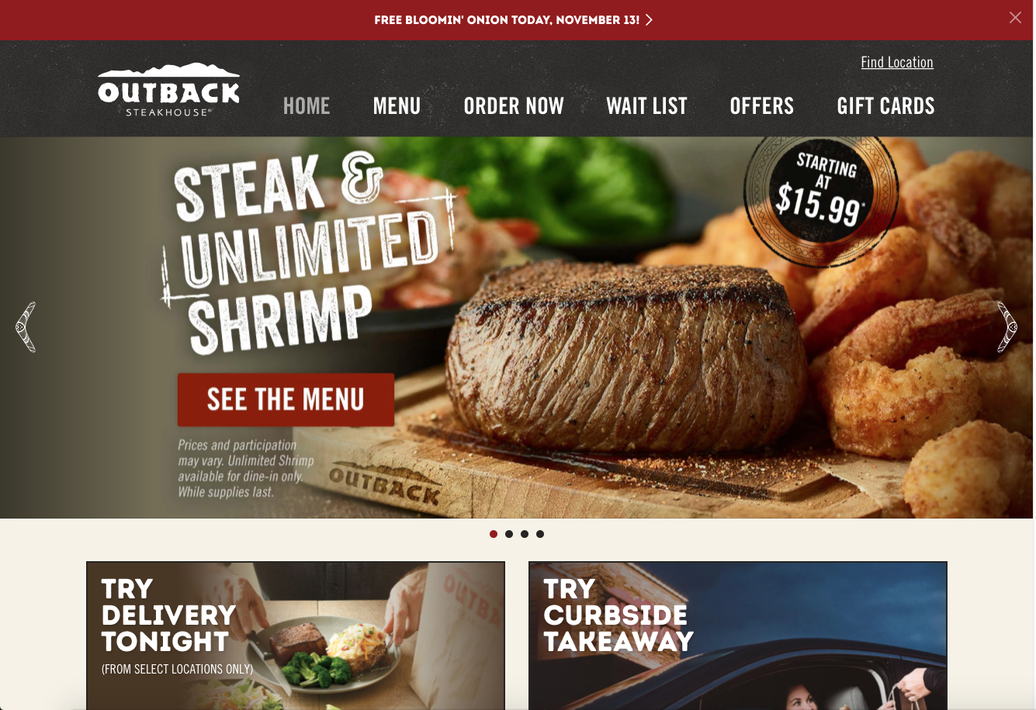

Large navigation bar

Few items in slider, and slider moves slowly

Figure 3.1: Home page isn’t overly busy, and color scheme roughly follows 60-30-10 rule. Navigation bar is large and informative, and slider is slow moving with few images.

## **Menu**

If we navigate as user Jane Doe would, we would attempt to locate the menu for Outback to view food items and pricing. The menu on this site is very easily accessible as it is one of the main navigation options located on the navigation var. Clicking on the menu navigation option shows us the menu directly, and does not redirect us to another site or require us to download a PDF of the menu to view. Additionally, the menu is not location specific, and navigating the menu itself is easy due to the large navigation text within the various menus offered. This reduces the total number of clicks needed by the user, thus improving overall usability and friendliness. All of this can be seen in **Figure 3.2.**

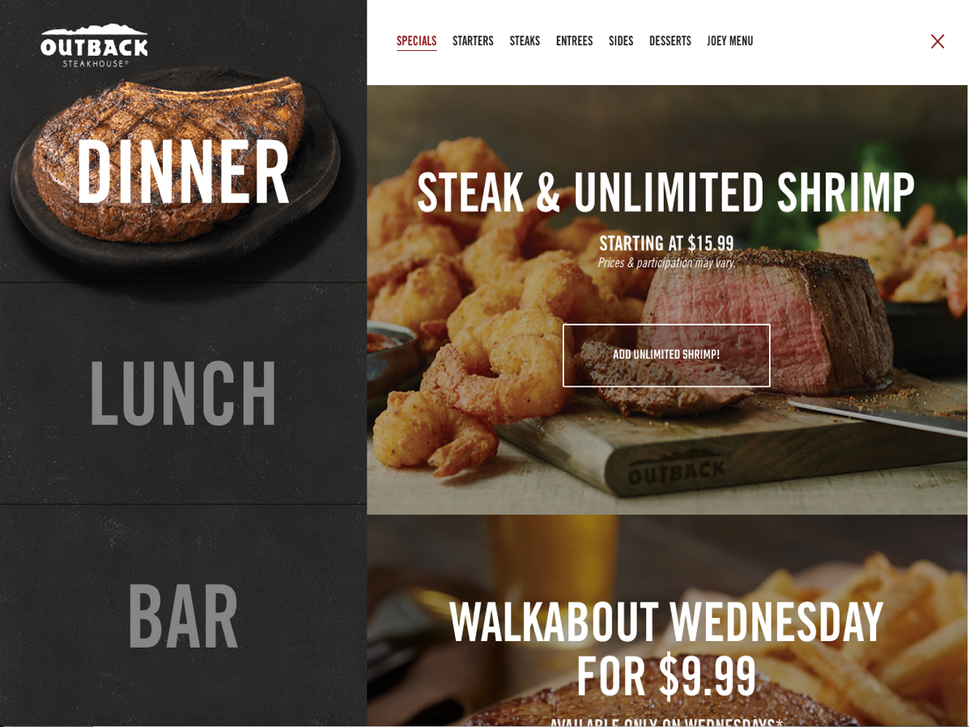

Easily navigable and informative menu headings

Menu is native to website, with large navigation buttons

Figure 3.2: The menu available on Outback Steakhouse’s website is easily navigable, shows prices and menu items clearly, and is native to the original website (doesn’t require redirection to another site / downloading a PDF)

## **Call Ahead / Wait List**

Finding call ahead and wait list information for a specific Outback location, something that user John Smith would attempt to do, is easy and intuitive on Outback’s site. One of the main navigation options on the navigation bar is labeled “Wait List”, and clicking on this option leads us to the call ahead / wait list page. This page has very little unnecessary text and is uncluttered. A text box prompts user to enter the zip code they are in, and then displays Outback’s that are local to that zip code. This is a much more intuitive way of searching for specific information than a drop-down menu. Contact information is displayed clearly after specifying a zip code, and a map is displayed next to the listed contact information for a more exact location description. Finally, these features are native to Outback’s site, and do not require any redirections or downloads. All of this can be seen in **Figure 3.3.**

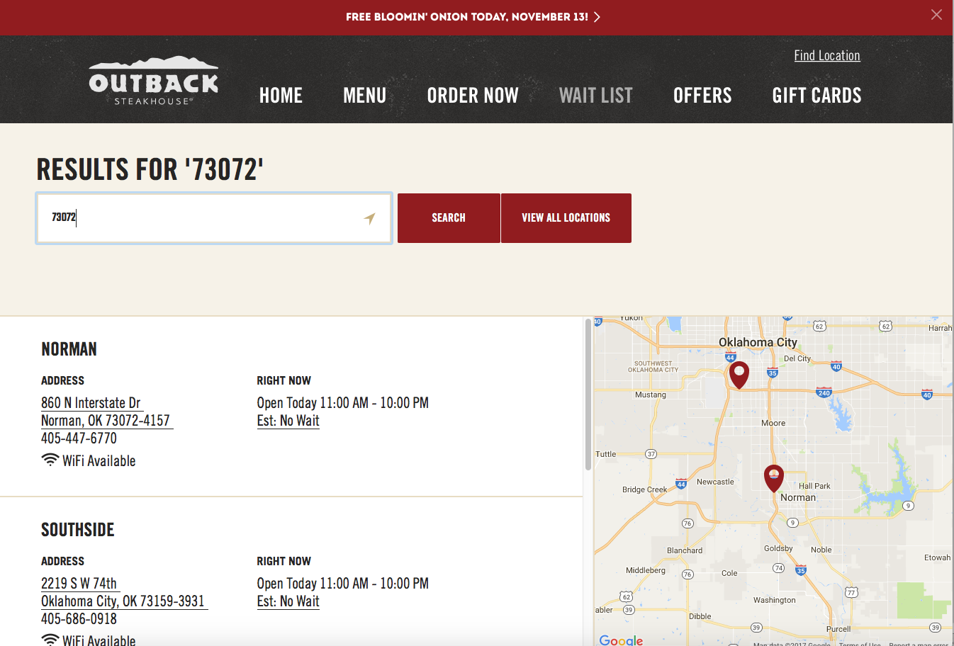

Search for specific zip code, rather than a drop down

Contact info and address easily viewable

Map available showing exact location

Figure 3.3: Searching for call ahead information is easily done on Outback’s website through their “Wait List” page.

## **Career Information**

If we navigate like user Ron Swanson would, we would attempt to find information about available positions at outback as well as information on how to apply. Obtaining this information on Outback’s site is native to the site itself, and can be found by clicking on the “Careers” navigation option. This page allows us to search for job openings based off a number of different criteria that can be selected through different drop-down menus that are large and clearly visible. When we select a specific position, the page does redirect us to the restaurants parent site for application information, but this is only done after finding available openings for specified positions, rather than when clicking on the “Careers” navigation option. All of this can be seen in **Figure 3.4.**

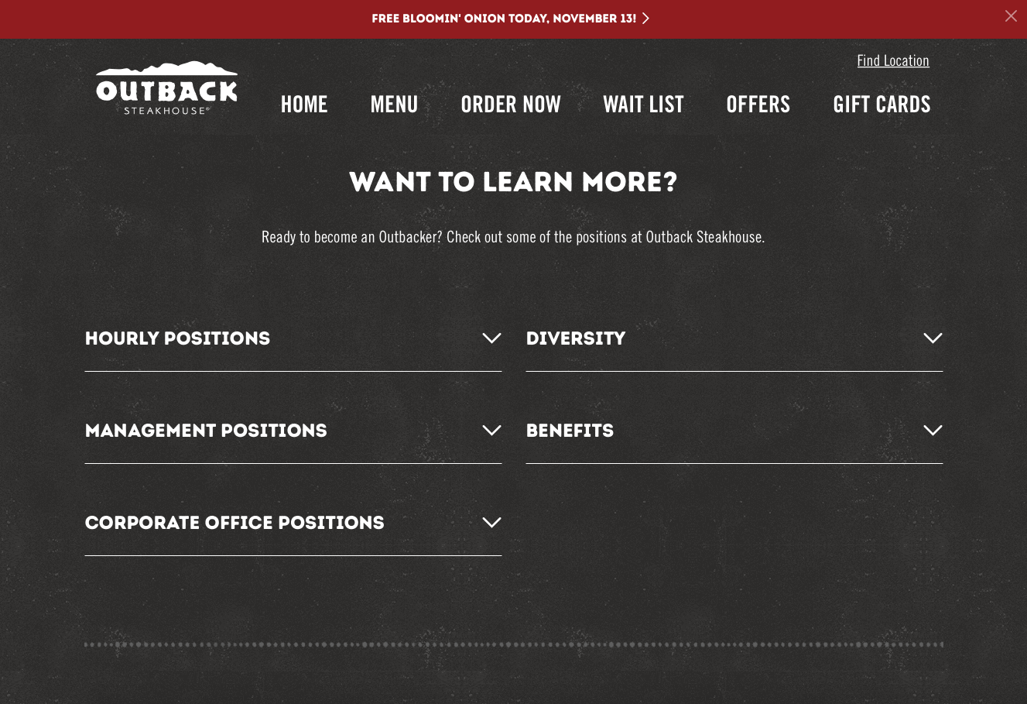

Career search through position & location

Native to outback.com

Figure 3.4: Finding career information is native to ouback.com, and searchable by position and location.

# **Proposal**

In conclusion, we recommend that you allow us to run a usability test for your website. Usability tests are a series of tests designed around “watching people try to use what you’re creating/designing/building (or something you’ve already created/designed/built), with the intention of (a) making it easier for people to use or (b) proving that it is easy to use.”[1] Essentially, this test will allow us to find specific areas of improvement for your site through actively testing users on specific tasks.

We propose a quantitative usability test (one which seeks to prove something, in this case whether your site is user friendly) which will involve asking participants who have never used your website before to perform basic functions and / or search for specific information on your site. This test will be in a controlled environment, and all information from the test will be observed from members of our team to determine pain points and areas for improvement for your site.

Since a large part of your site’s traffic will be searching for a menu to view food items and pricing, call ahead for seating, and gaining information on applying for a server position at Saltgrass, a majority of this usability test will be focused on completing objectives involving these three areas. We will ask users to perform the following tasks:

* Navigate to a dinner menu from the home page, and find the price of a cheeseburger.
* Navigate to a page containing contact information for the Norman, Oklahoma Saltgrass location.
* Navigate to the applications page for a server at Saltgrass

In order for a usability test to be considered quantitative, specific data points must be collected and analyzed so as to measure the success rates of assigned tasks. We will use the following quantitative data to measure the overall usability of your site:

* Total time for completing each task
* Total number of clicks it takes to complete a task
* Total number of misdirections (navigating to an area of the site which does not contain information leading to or information pertaining to the completion of a task)

This testing will be done by outlining the above tasks for a user and observing the user complete said tasks with as little interaction from those giving the test and those taking the test as possible so as to avoid influencing the results. The user taking the test will be observed by 3 people in total: a narrator who will outline the tasks for the user, a note taker who will observe the test and its participant, and a follow up observer who will ask extra questions during and after each task is complete.

Upon completing this usability test, we will report back to you on our findings with this quantitative information, and work with you on possible solutions for your site if you so choose.

1. Steve Krug’s *Rocket Surgery Made Easy: The Do-It-Yourself Guide to Finding and Fixing Usability Problems*